# QRG – Order Classes

Order Class is a critical part of the NAXT solution, all users need to have a basic understanding of it’s function as it impacts most modules of NAXT.

## What is it?

Order Class is a critical setting in NAXT that:

* Restricts what a user can initially see on list pages
* Decides the financial dimensions used on a financial posting
* Impacts the behaviour of different forms
* Impacts the format of printed forms
* Impacts what items a user can use in a transaction
* Impacts the foreign currency rate a user can use

## Order Classes

There are a number of Order Classes which reflect different areas of business operation. Workers will be provided with the relevant Order Classes for their work. All workers should have the two Order Classes used for procuring expense items being ITEM SERV and OVERHEADS available to them.

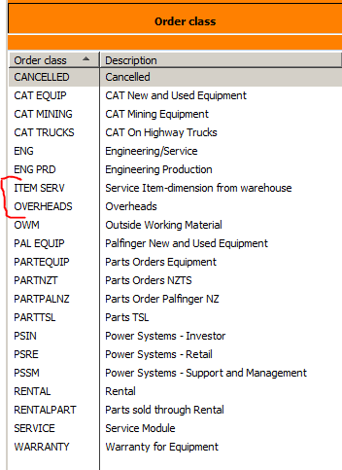

## Order Class set at your worker record

*Screenshot of Worker Record*

*Default Order Class Assigned Order Classes Not Assigned Order Classes*

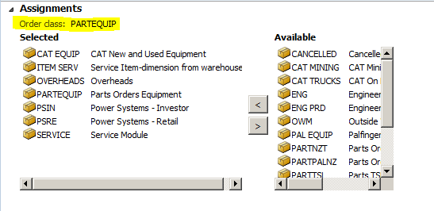

* If you believe you do not have the correct Order Class request the missing one via ITSD and your line manager (will be subject to business owner sign-off)
* Default Order Class impacts how hyperlinks to a supporting document work, ie if you click on the link to a PO document which is does not belong to your default Order Class you will go to the next PO in the number sequence that is raised in your default Order Class.

## List pages initially only show your default Order Class. You can remove or change the defaulted Order Class:

You can amend your view by selecting the Order Class filter dropdown and selecting any of the other Order Classes assigned to you. Alternatively you can highlight your current Order Class and then select delete, this will allow you to view all Order Classes assigned to you.

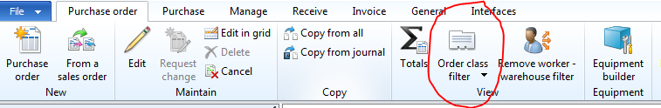

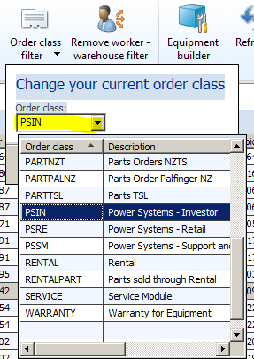

## Only available to change at the create new document stage:

We can only set the Order Class as we create a document ie

Create New Service Call

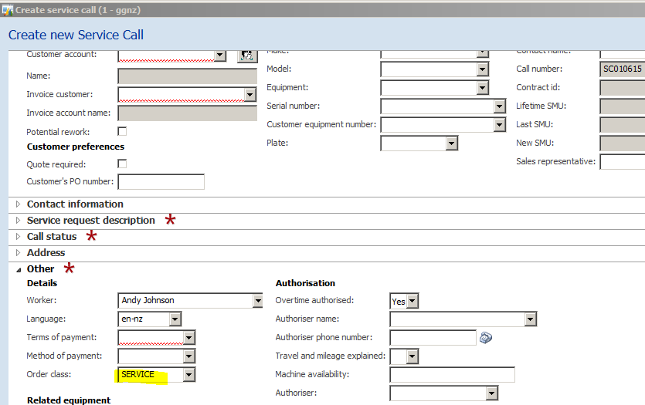

Create New Sales Order

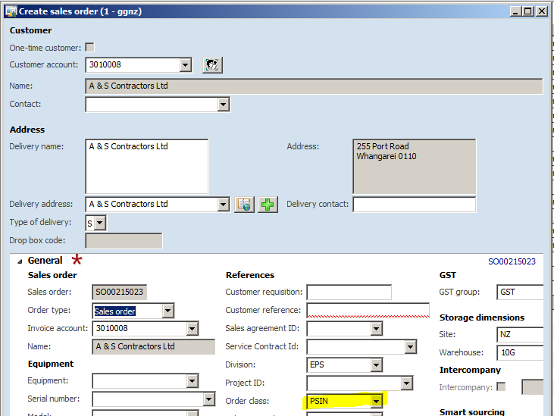

Create New Purchase Order

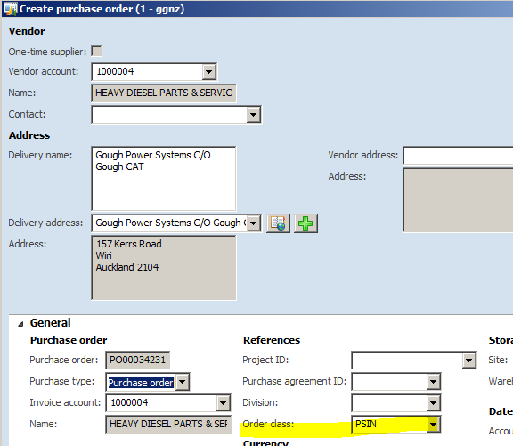

## Currency

When purchasing in foreign currency:

* An exchange rate type populates on a PO from your Order Class
* Only change in the following circumstance
  + If finance have purchased you a specific forward contract then you can change the rate type to a contract type that is specified for your Order Class
  + You then select the specific contract from the contract drop down

